Marca Bristo, Influential Advocate for the Disabled, Dies at 66
Paralyzed in an accident at 23, she devoted her life to changing perceptions of the disabled and was a key player in passing the Americans With Disabilities Act.
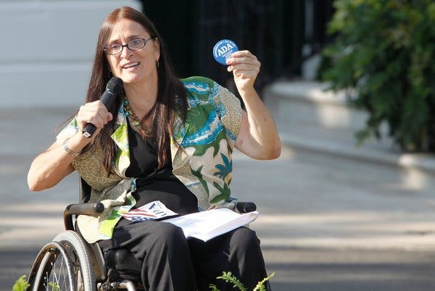
Image
Marca Bristo speaking at a White House event in 2010 marking the 20th anniversary of the Americans with Disabilities Act. She was a longtime leader in the fight to address the needs of the disabled.

By Glenn Rifkin
- Sept. 8, 2019
When she was 23, Marca Bristo, a nurse in Chicago, was sitting with a friend on the shore of Lake Michigan. Her friend’s dog accidentally knocked a prized pair of Ms. Bristo’s shoes into the water and, without a second thought, she dived in to retrieve them.
Striking her head, she broke her neck and was paralyzed from the chest down. In that instant, Ms. Bristo’s life changed forever in ways she could never have anticipated. She lost her job, her health insurance, could no longer use public transportation and had no access to many public places.
But rather than dwell on her misfortune, she became a powerful advocate for people with disabilities, spending her life working to change perceptions and the rules in a world that had traditionally ignored the needs of the disabled. She was a key player in the passage of the Americans With Disabilities Act of 1990, which outlawed discrimination against the nearly 50 million Americans with disabilities.
After a long battle with cancer, Ms. Bristo died on Sunday at 66 in her home in Chicago. Her death was confirmed by her husband, J. Robert Kettlewell.
Her career as an advocate for the disabled lasted more than four decades and influenced several presidential administrations. Her success in reshaping Chicago’s policies for the disabled formed the basis for national and international legislation as Ms. Bristo, in her motorized wheelchair, traveled around the world to promote her vision for independent living.
Her passion reflected her own life philosophy; she refused to allow her disability to constrain her. She was married for 32 years to Mr. Kettlewell and they had two children. She recently became a grandmother.
“She focused on her ability, not on her disability,” said Valerie Jarrett, a senior adviser to President Barack Obama, who met Ms. Bristo in Chicago in the mid-1990s and later made her an adviser to the Obama administration. “There wasn’t a policy decision we made over those eight years that would affect the lives of people with disabilities, without consulting Marca,” Ms. Jarrett said in an interview for this obituary on Saturday.
In 1980, Ms. Bristo founded Access Living in Chicago, a nonprofit that promoted independent living for the disabled.
Access Living reshaped Chicago’s landscape for the disabled and became a model for cities across the country, and from that, Ms. Bristo founded the National Council on Independent Living, which she led for many years.
In 1993, President Clinton nominated her to head the National Council on Disability. She served in that role until 2002. She was elected president of the United States International Council on Disabilities and traveled around the world to promote efforts on behalf of the disabled.
“Marca Bristo’s trailblazing leadership and bold strategic vision secured historic progress for every American with a disability and their families,” House Speaker Nancy Pelosi said in a statement. “With Marca’s passing, our nation has lost an extraordinary champion for the rights of people with disabilities.”
Her signature achievement was helping to pass the A.D.A. She was a protégée of Justin Dart Jr., vice chair of the National Council on Disability, and someone Ms. Bristo referred to as the “Martin Luther King of the disability rights movement” in a 2015 blog celebrating the 25th anniversary of the A.D.A.’s passage. They worked closely and she made pointed suggestions for ways to improve the legislation.
“My husband spotted her to be a future leader,” Yoshiko Dart said of Mr. Dart, who died in 2002. “She had principle and passion and wasn’t afraid of saying things to people. She insisted on justice for all types of people.”
In the 1980s, as a member of United States Task Force on the Rights and Empowerment of Americans With Disabilities, she connected with then-Congressman Tony Coelho of California, who, along with Senator Lowell Weicker of Connecticut, introduced the original A.D.A. bill to the 100th Congress in 1988. In her role, Ms. Bristo helped draft and amend the bill that eventually made its way to the president’s desk two years later.
“She was one of the strongest advocates, from the grass-roots side,” Mr. Coelho said in an interview on Saturday. “To a great extent, without the grass-roots effort, we wouldn’t have gotten the A.D.A.” Not content with the passage of the bill, Ms. Bristo spent the rest of her life making sure it was consistently implemented.
Marcia Lynn Bristo was born on June 23, 1953, in Albany, N.Y., to Earl Clayton Bristo and Dorothy Madeline Bristo. She spent her childhood on a family farm, along with her older brother, Paul, and sister, Gail, in Castleton, N.Y. before the family moved to West Winfield, N.Y.
ADVERTISEMENT
She spent her senior year of high school in the Philippines and went to Beloit College in Wisconsin in 1971. At freshman orientation, an upperclassman nicknamed her Marca and the name stuck. She got her nursing degree from the Rush University College of Nursing in Chicago in 1976, intending to be a midwife, and worked at Northwestern Medicine Prentice Women’s Hospital in the labor and delivery unit.
She met Mr. Kettlewell in 1986 when he was chief of staff for the Illinois congresswoman Cardiss Collins, and the couple married in 1988. She gave birth to a son, Samuel, and a daughter, Madeline. Her granddaughter was born in July. They, and her sister, Gail Bristo Smith, survive her.
After her accident, Ms. Bristo became acutely aware of the impediments she would face. “People immediately treated me differently because of my wheelchair,” she wrote in a 2015 Chicago Tribune column. “In spite of my activist spirit and the historical civil rights context in which I was raised, I was on my own to cope with this new reality.”
When she later attended a conference on disability in Berkeley, Calif., she got a glimpse of an environment with a completely different attitude toward people with disabilities. The city, with a history of activism, had curb cuts, accessible buildings and bathrooms, and the buses had wheelchair lifts.
“No longer did I see curbs or stairs or inaccessible buses and bathrooms as a problem around which I needed to navigate,” she wrote. “Rather, I saw them as examples of societal discrimination — and felt a responsibility to get involved to help people with disabilities, in Illinois and beyond.”
She became part of a growing movement. “This ragtag army of people who couldn’t see, hear, walk and talk did what everyone said couldn’t be done,” she said. “We passed the most comprehensive civil rights law since the passage of the 1964 Civil Rights Act.”
Edward M. Kennedy Jr., son of the late Massachusetts senator and currently the chairman of the American Association of People With Disabilities, met Ms. Bristo in the mid-1980s and said “she had an immediate impact on me.”
Mr. Kennedy, a former state senator in Connecticut, lost a leg to cancer in 1973, when he was 12. “She reframed the disability experience as a civil rights issue, as opposed to a medical issue,” Mr. Kennedy said on Saturday. “She was one of the pioneers trying to change the way people with disabilities thought about our circumstances. She used to talk about what she called ‘the internalization of oppression’ that existed in other civil rights struggles.”
“She was a force of nature,” Mr. Kennedy added. “In both her personal life and political life, she was a role model for millions of people with disabilities in our country.”
Ever the advocate, in the days before her death, Ms. Bristo received a phone call from Ms. Pelosi. According to her husband, the Speaker wished her well and said “I wish there was something I could do,” to which Ms. Bristo quickly replied: “You can. Move the Disability Integration Act to committee and to a floor vote.”

Obituary taken from September 8, 2019 New York Times

